
Senior Design Program
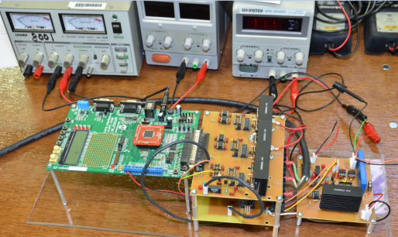
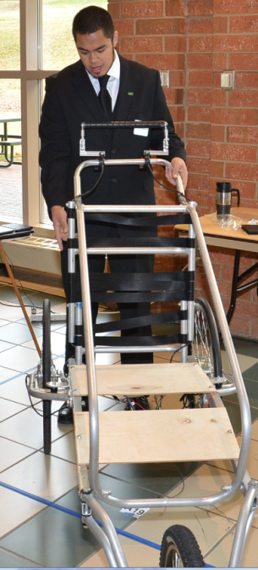
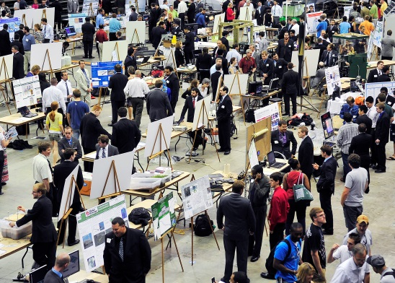

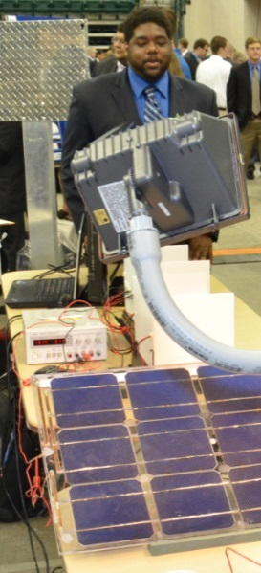
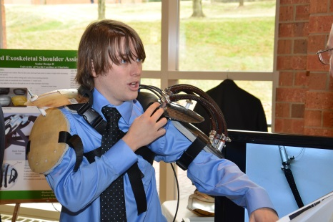
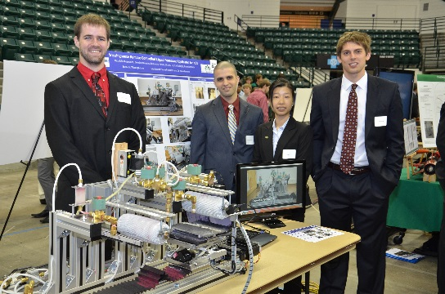

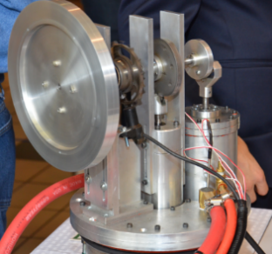
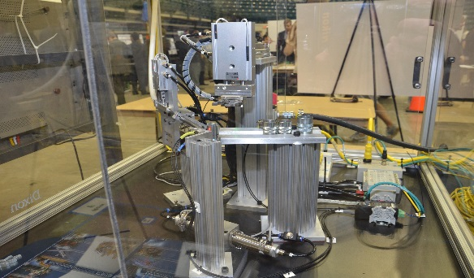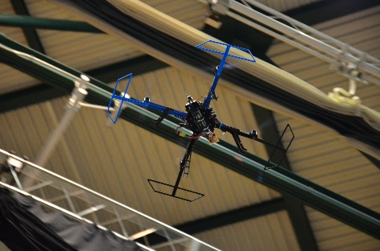

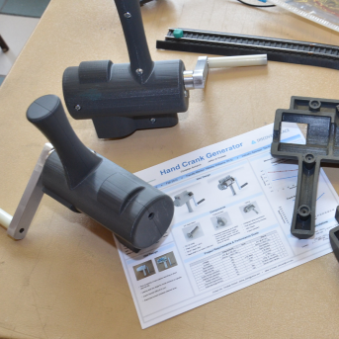
Industrial Solutions Laboratory
(704) 687-5029

www.isl.charlotte.edu
coesrdesign@charlotte.edu

Senior Design
The Lee College of Engineering Senior Design program brings together students, faculty, and industry partners in a collaborative environment of research, design, and application. Students work on multi-disciplinary teams to tackle engineering problems. The experience simulates the real world as students manage budgets, deadlines, and conflicting restraints to provide a solution that meets the needs of the industry supporter.

Students benefit from:
- Getting practical real-world experience prior to graduation
- Applying engineering design practices
- Balancing conflicting constraints and requirements
- Developing team problem-solving skills
- Managing projects to complete on schedule and within budget
- Developing specialized fabrication skills
- Meeting customer’s requirements
- Working with engineering professionals
- Interacting with potential employers
- Learning about the engineering workplace

Industry supporters benefit from:
- Initiating elective research projects
- Collaborating with UNC Charlotte faculty
- Creating prototypes of new or improved products
- Improving manufacturing or business processes
- Evaluating the technical and non-technical skills of students
- Screening potential new hires
- Contributing to the academic program
- Networking with students, faculty, and other industry partners
- Promoting their company and corporate name recognition

Expectations

Students are expected to have the necessary technical knowledge to complete projects. They should dedicate 10 hours per week or a total of 250 hours per student to their project. Besides in-class activities, this time includes planning, research, design, purchasing, fabrication, testing, analysis, evaluation, risk assessment, and oral and written communications. A common basis is used to evaluate student performance across all engineering disciplines. Upon completion of the industry-supported design project, students are expected to better understand real-world expectations and performance requirements and be better prepared to successfully transition into the workplace.

Industry Supporters of Senior Design projects should have a product or project in mind with well-defined requirements and constraints. The scope should be suitable for a multi-disciplinary team of 4-6 students (typical but not limited to this size) working steadily for approximately seven months. Supporters provide a tax deductible financial contribution to help defray the costs of materials and supplies, tooling, off-campus travel, use of campus facilities including engineering shops and laboratories, and administration of the College of Engineering Senior Design program and events. Supporters should also provide regular guidance, feedback, and encouragement to the team through a designated technical representative, so that important design issues are resolved promptly and satisfactorily.
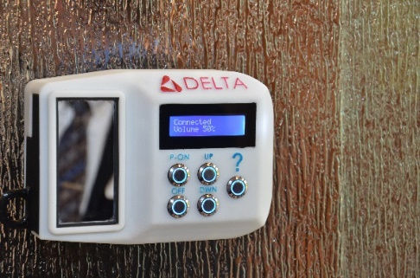

Projects
Innovative projects that span the engineering disciplines are encouraged. This gives students an opportunity to experience the multi-disciplinary teamwork they will encounter in industry. Teams may include students from civil, computer, electrical, mechanical, and systems engineering and engineering technology. Projects may begin in August with a completion date of May or in January with a completion date of December.
Characteristics of Good Projects
- Projects should be defined by a solid statement of work and requirements.
- Deliverables should be clearly articulated.
- Projects should be multi-disciplinary and capable of being completed within the prescribed work envelope.
- Project goals should allow ample time for prototype testing as appropriate.
- Complex projects should consider large or multiple teams.
- Project prototype must be fabricated using on-campus equipment and facilities or at the industry supporter’s facilities.
Becoming a Supporter
- Submit a one-page description of the intended project by May 1/Nov 15 (fall/spring).
- Identify a technical representative to work with the team by Aug 15/Jan 3 (fall/spring).
- Upon approval of scope and staffing of the team, provide tax-deductible corporate donation by Oct 15/Jan 1 (fall/spring).
- Attend the Senior Design Breakfast to meet the project team and articulate initial project requirements.
- Regularly provide feedback to the team as work progresses.
- Attend formal design reviews to evaluate progress and results.
- Attend the Senior Design Expo at the end of each semester.

Some Recent Projects
Liberty Hardware Sound Integration into a Shower
The Sound Integration into a Shower project was supported by Liberty Hardware. The project consisted of the design and fabrication of a device that incorporates sound into a shower door. The device is water resistant, runs on a rechargeable battery that lasts six hours between charges, and is blue tooth compatible.
RFMD Analysis and Design of PCB Traces for Cellular Frequencies

Supported by RFMD, students researched, analyzed, designed, and fabricated a printed circuit board that provides a reduction in signal loss for cellular frequencies by more than 10 percent.
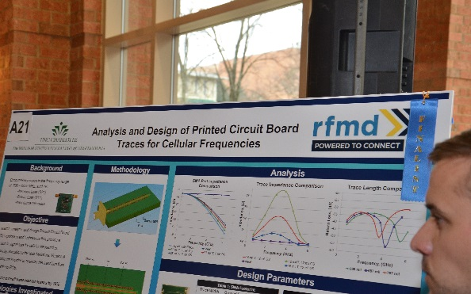

ENVENTYS Wave Energy Conversion

Supported by ENVENTYS, the wave energy conversion project consisted of design and construction of an ocean platform that uses wave energy to produce and store compressed air that drives a reverse osmosis unit for desalination of sea water.

